LENDING CLUB DATA ANALYSIS-ML

Applying machine learning models to the data and deploying best model in Azure



**Pranay Mankad**

**Priyesh Kaushik**

Data Download and Cleaning Pipeline:

Steps followed –

1. Install Apache – airflow using pip on python bash.
2. Initialize db using command airflow “airflow initdb”
3. Run apache airflow on the webserver using “airflow webserver –port 2405”
4. Take a look at the console.
5. Create a python script file with defined DAGS and process.
6. Push python script to defined path for airflow home and restart the webserver.
7. To run, go to the web console and press the run button on the right hand side of your task name.
8. Wait and watch.

Screenshots:

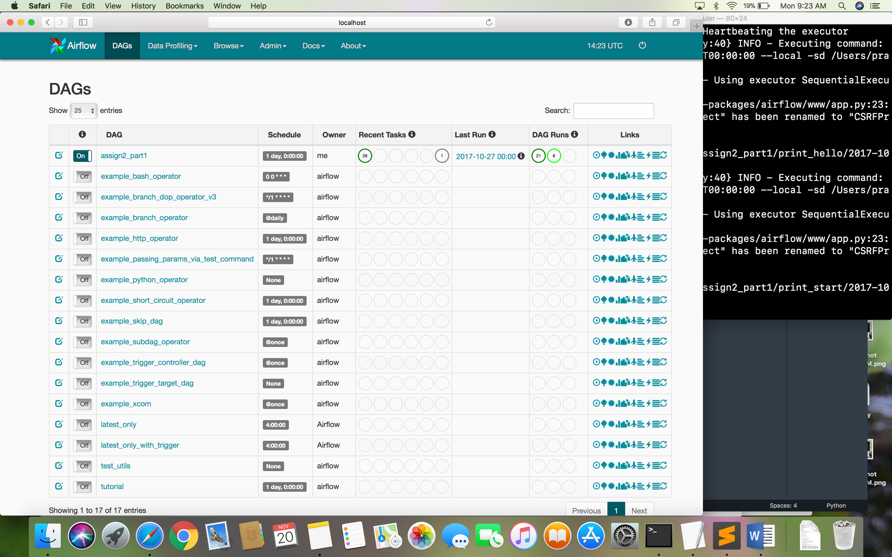

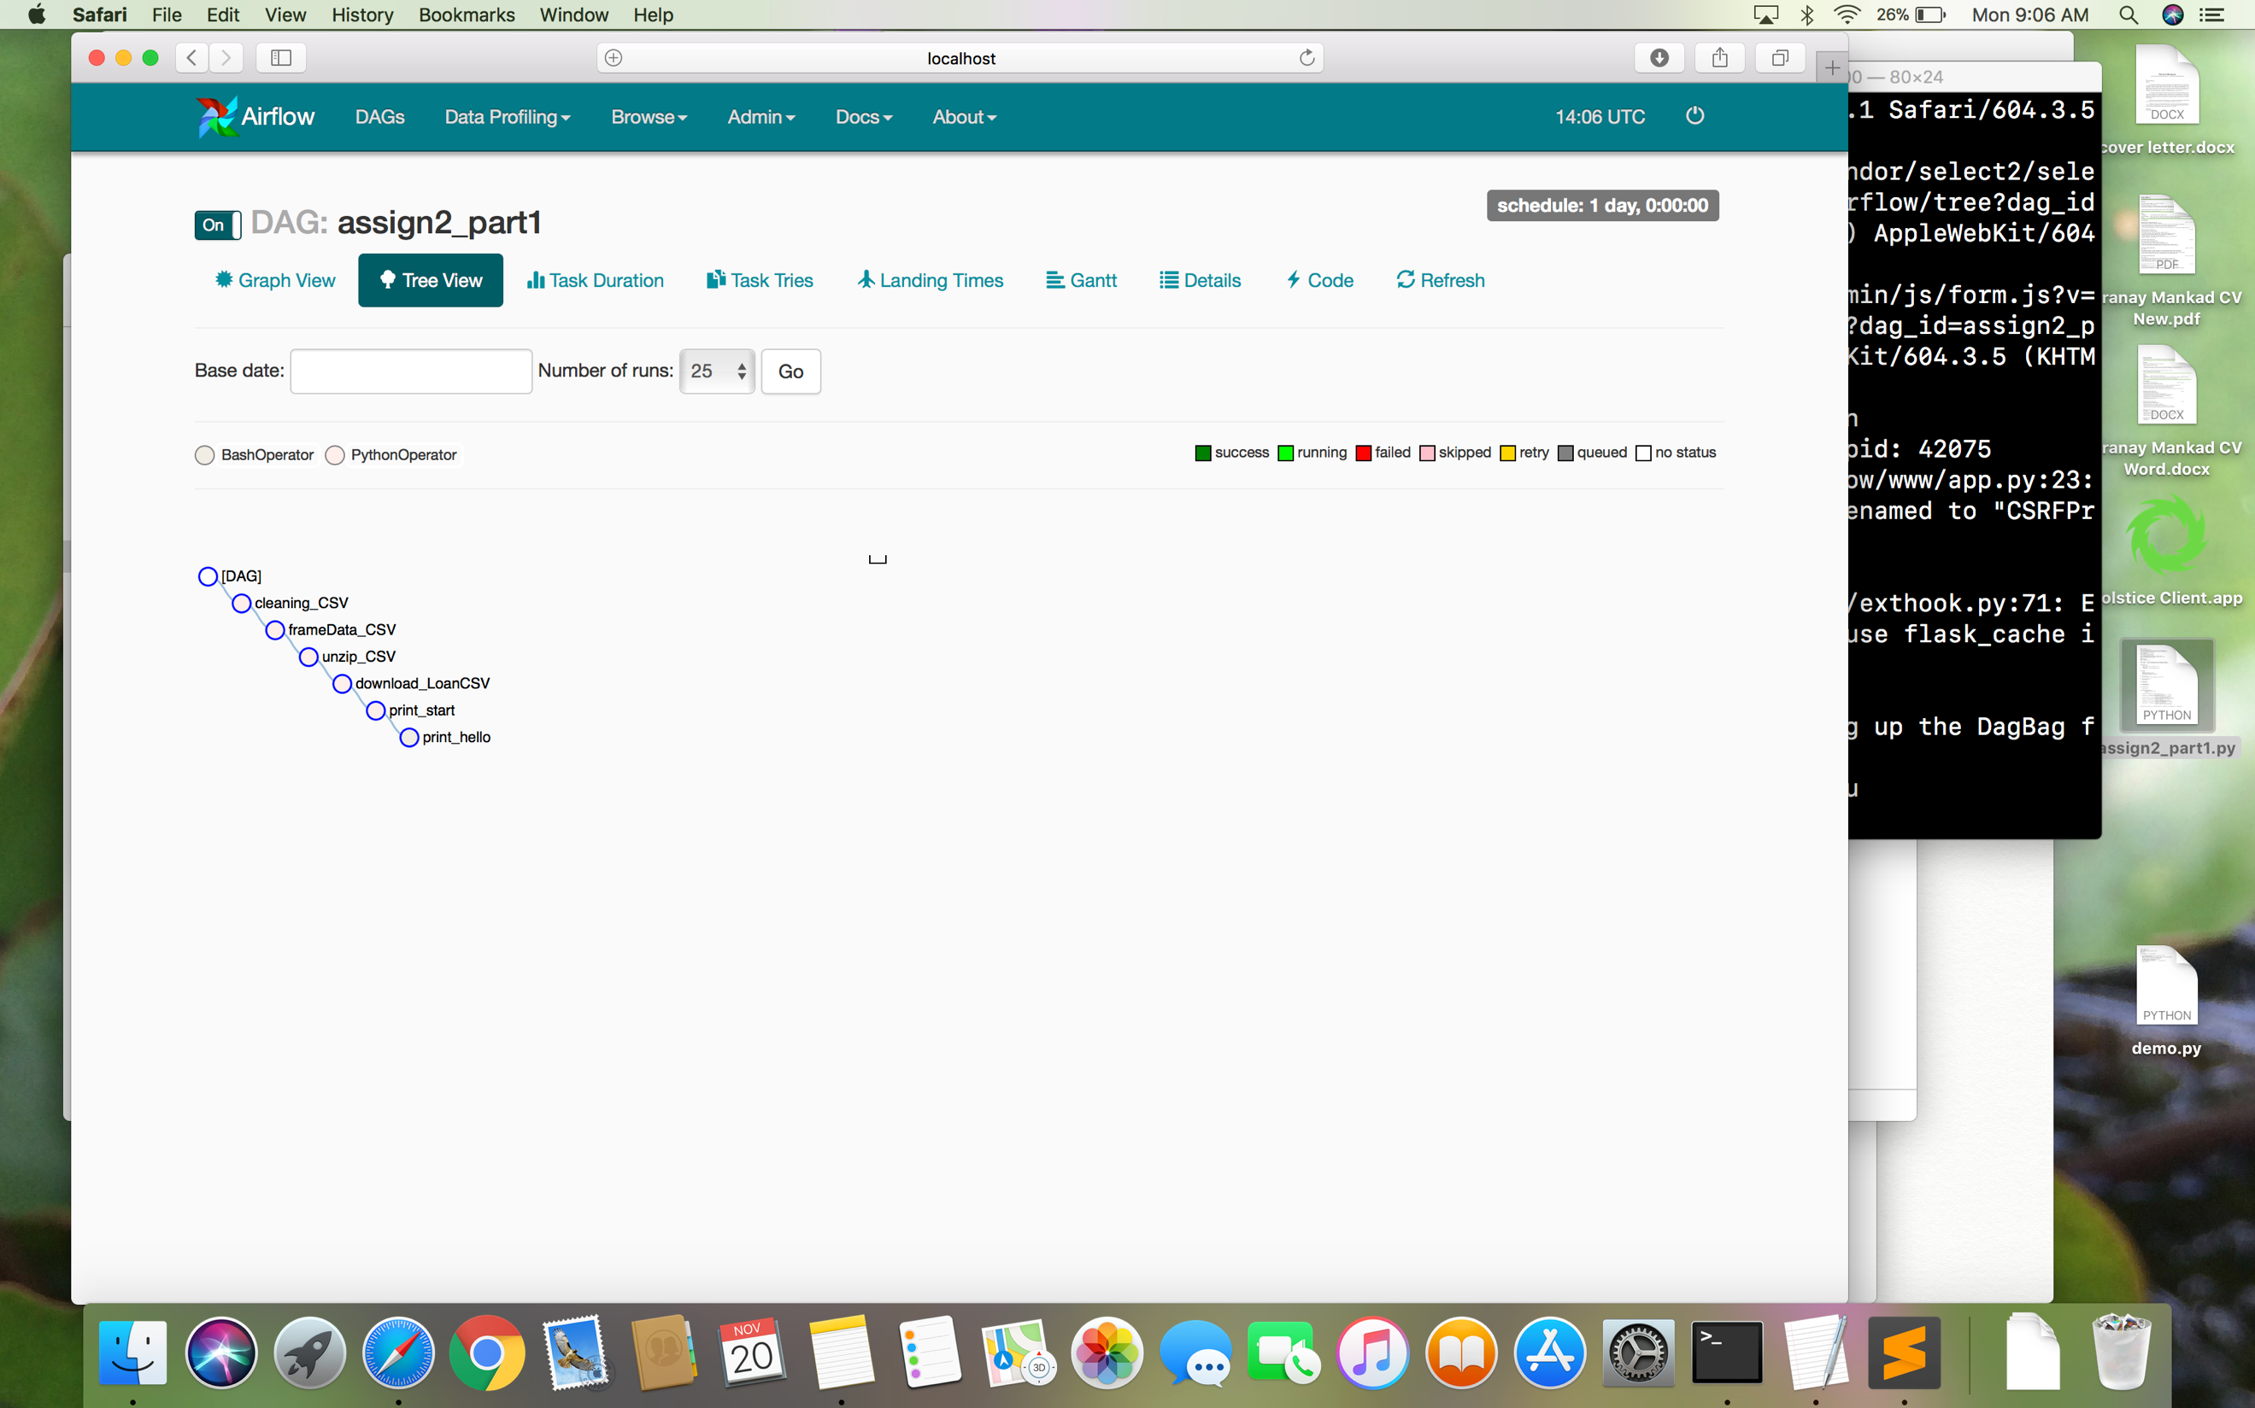

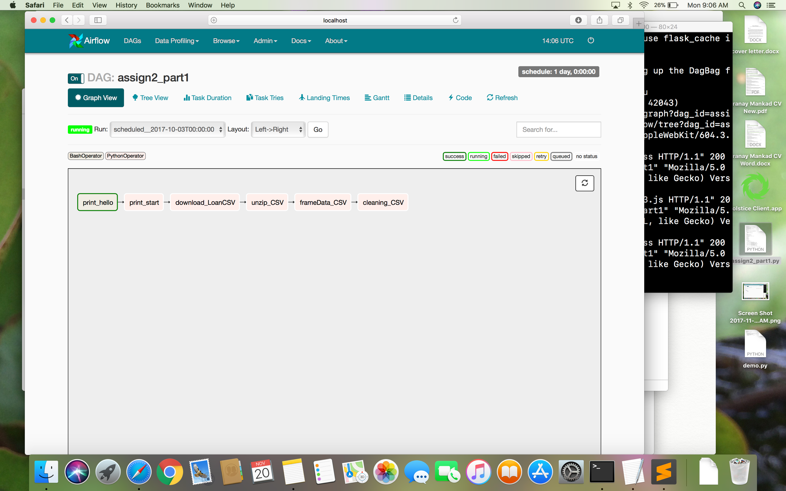

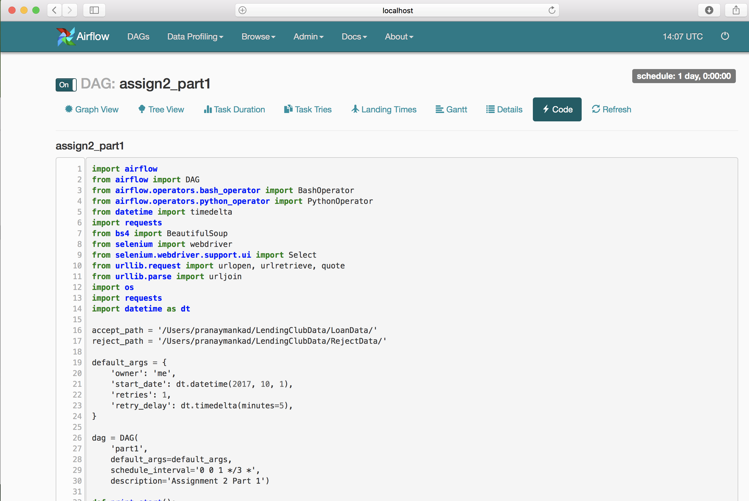

Processes followed in the automation:

* Run the script every 3 months, chron schedule mentioned above.
* Login and download files to two separate folders.
* Unzip and load data on to a dataframe
* Use dataframe to analyze and clean data, store on parent folders root.

The processes happen sequentially and do not happen in parallel, unless specified.

To run the process without the webserver staying open, just run the scheduler provided with airflow.

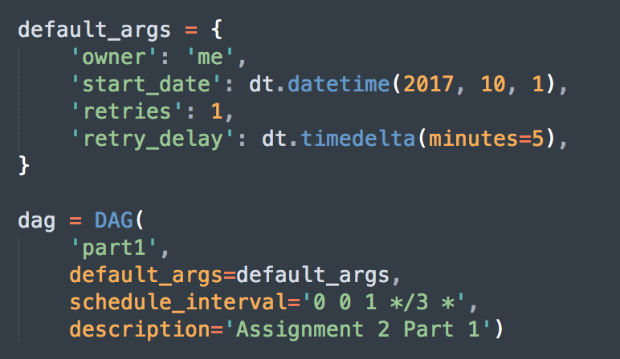



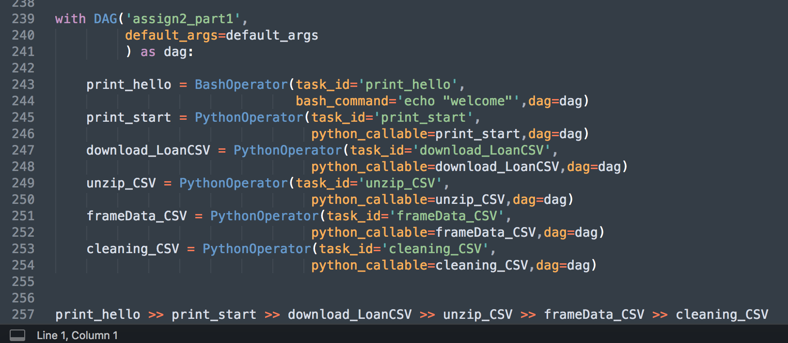

Defining Dags and The DAG process.